“Installation”

Prerequisites:
- Install PowerShell Version 7
  - Version 7.3.6 is located at \\al001mgmg01.us.chs.net\Software\Microsoft\PowerShell
- PowerShell modules:
  - Posh-SSH
  - PowerCLI
* If you don’t have the modules installed, at first launch
Dell XC Manager will prompt you and ask if you’d like to install them from the PowerShell Gallery. If you click yes it will attempt to automatically download and install them for you.

Download this folder to your desktop:
\\al001mgmgt01.us.chs.net\SoftwareDell\Dell XC Manager

After you download it, to launch it, double-click “Nutanix Management Console”.
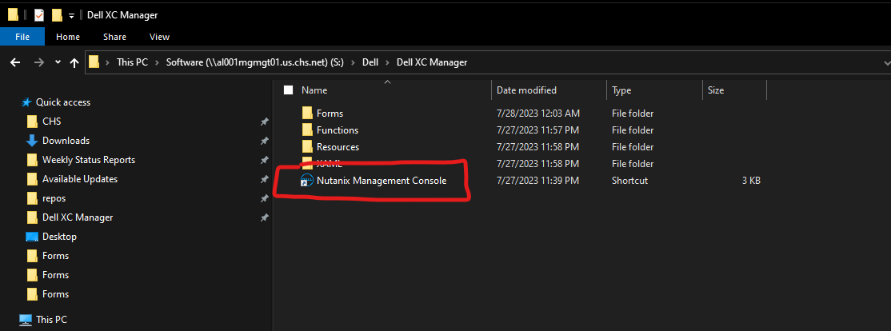

Saving Credentials
It is highly recommended to go to options and save your credentials before attempting to add any clusters to your inventory. The credentials are only saved in memory and are explicitly removed when the application is closed. If you do not save credentials, you will be overwhelmed with prompts for credentials because you will be prompted for every single connection made to any cluster, CVM, iDRAC, host, vCenter, and Prism Central. And multiple connections are made to each CVM and iDRAC for every single host.
- Click “Options” button.
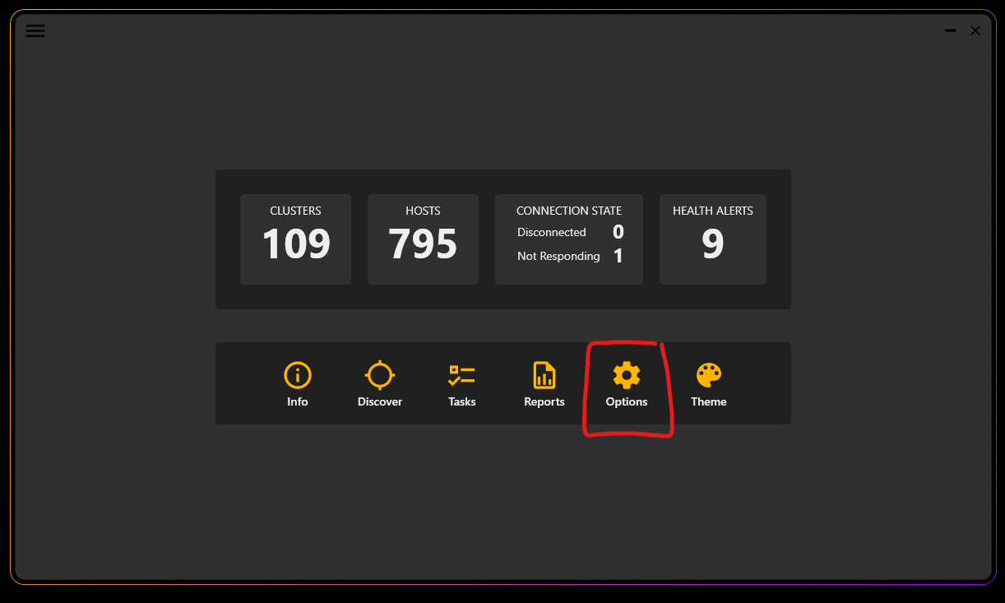
- Check the boxes next to Prism Central, Prism Element, vCenter, CVM, and iDRAC. Those are all needed to inventory. Hypervisor is only needed to interact with the iSM or PTAgent and to reset the iDRAC, which is not done during an inventory. You will be prompted to provide credentials each time you check a box. Be sure to check the box next to “Use Saved Credentials”.
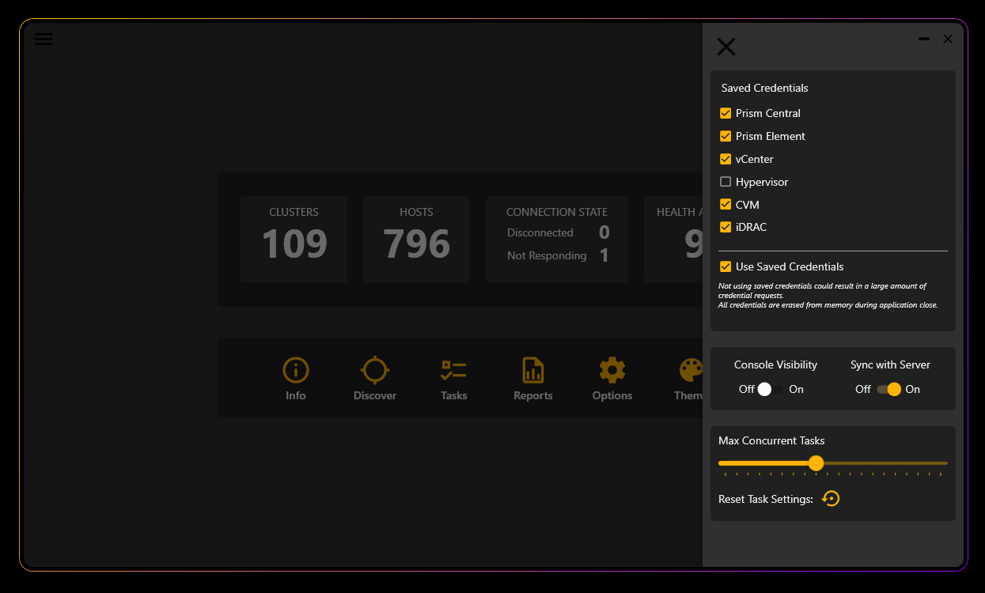
If you have a cluster with unique credentials from all the other clusters, you can either resave all of your credentials before running an inventory against it or uncheck the box next to “Use Saved Credentials”. Just be aware that you’ll receive a lot of prompts for credentials.

Inventory Clusters
- Click “Discover” button.
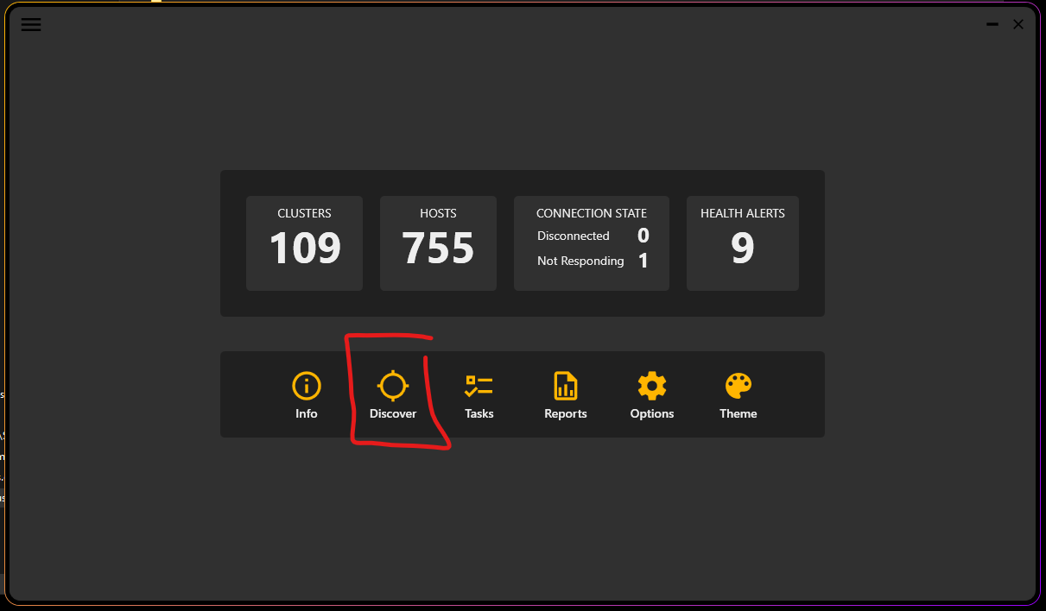

- Click in the text box that says “Prism Central IP.
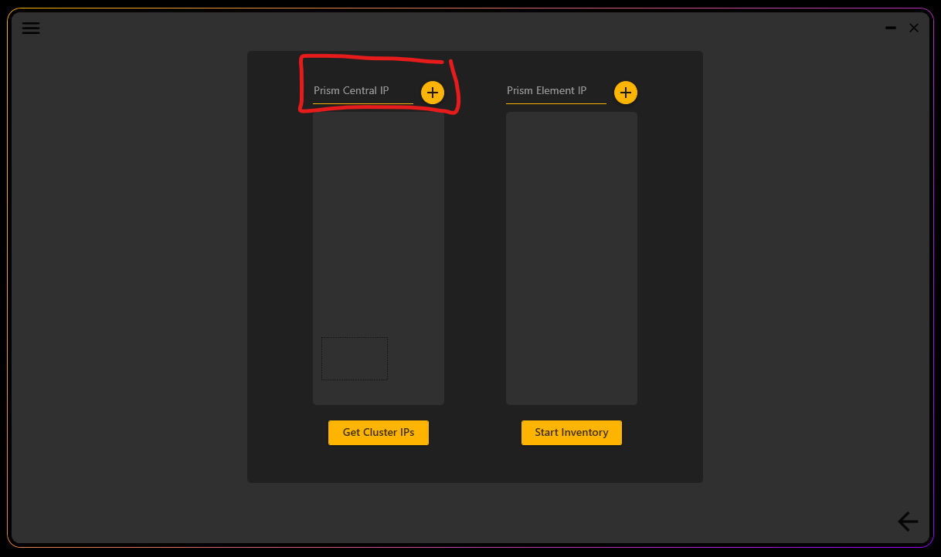

- Either type in the IP for the Prism Central you want to add to your inventory. More than one can be added by separating with a comma. Just press enter or click the “+” button and select add to add them to your inventory. Alternately, you don’t have to type anything in the textbox and can just click “+” and select “Import List” and import a txt file that has a list of all the IPs.
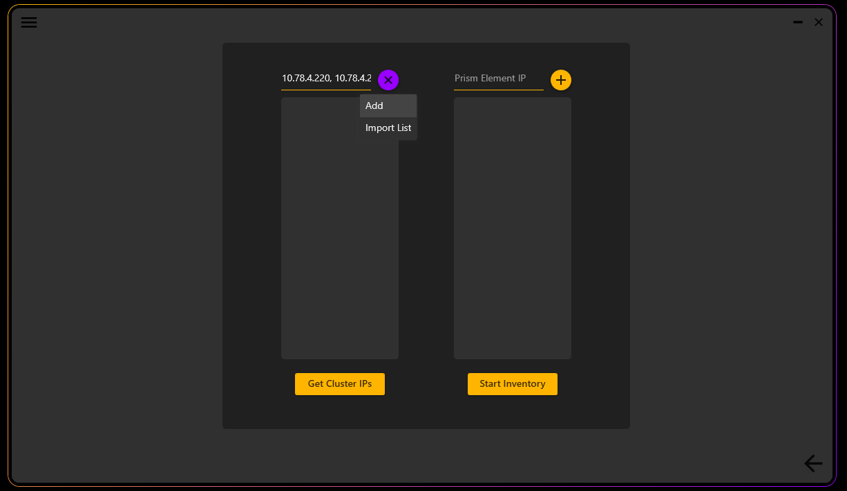

- Click on any Prism Central IPs you want to extract Cluster IPs from. Selecting multiple at once is supported by Shift+Clicking or Ctrl+Clicking. Then click on “Get Cluster IPs”.
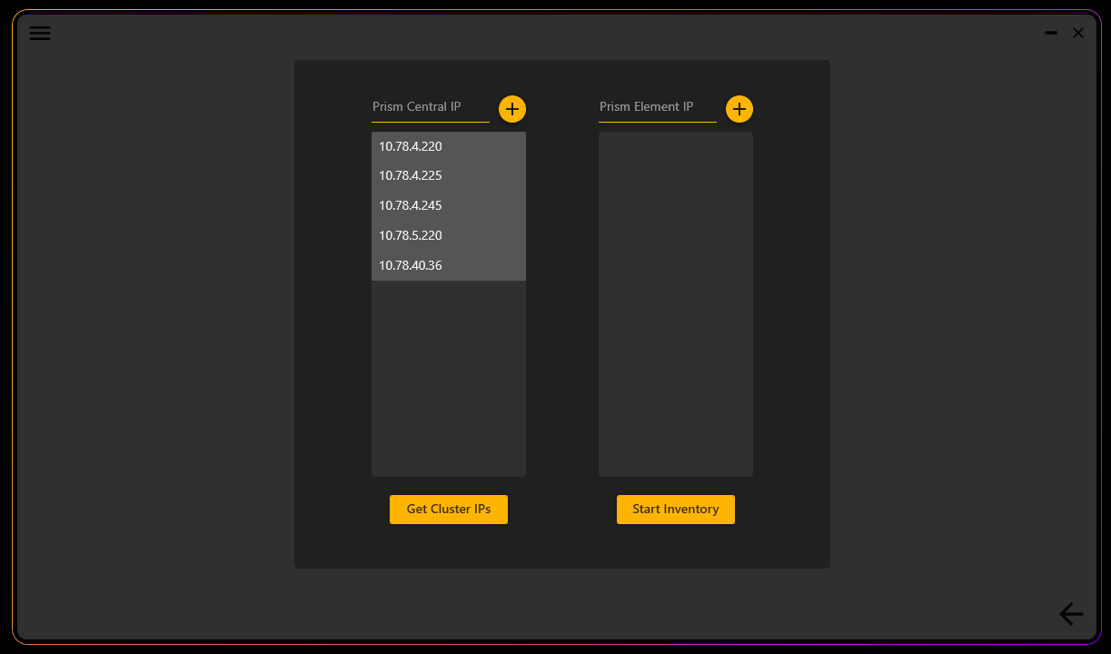

- Once inventory is complete, the Prism Element IPs will appear in the right listbox. This box works the same as the Prism Central listbox. You can also manually add IPs for clusters that are not part of Prism Central, the same way you supplied Prism Central IPs. If the cluster is already in your inventory then it will be highlighted in the same color you have selected as your primary color in your theme preferences, but with 10% opacity. This is to make it easy to determine if you have any clusters missing from your inventory that are registered in Prism Central.
